



**Module Code & Module Title**

**CC5068NI– Cloud Computing & IoT**

**Assessment Type**

**50% Group CourseWork**

**Semester**

**2022 Spring**

**Group members**

|  |  |
| --- | --- |
| **London Met ID** | **Student Name** |
| **20049139** | **Bikesh Parajuli** |
| **20049142** | **Bisham Kunwor** |
| **20049253** | **Sushila Gyawali** |
| **20049453** | **Ritesh Timalsina** |
| **20049261** | **Ujwal Bhattarai** |

**Assignment Due Date: 2022-05-09**

**Assignment Submission Date: 2022-05-09**

**Word Count: 2817**

*I confirm that I understand my coursework needs to be submitted online via Google Classroom under the relevant module page before the deadline in order for my assignment to be accepted and marked. I am fully aware that late submissions will be treated as non-submission and a mark of zero will be awarded.*

**Acknowledgement**

We'd like to thank the module teachers, Mr. Sugat Man Shakya and Mr. Sujil Maharjan, for allowing us to work on this IOT project on the topic of water monitoring and management, as well as for assisting us in performing thorough research and learning about many aspects of IOT. We're also grateful to all of our friends who helped us bring these concepts to life for our project. Despite their busy schedules, they came up with fresh ideas and made time to assist us with our project. Thank you again to everyone that assisted me.

**Abstract**

Most people in residential areas are running out of water and their water tanks are spilling due to an excess supply of water. Users' ability to gauge the quantity of water in water tanks becomes more difficult, leading in users running out of water when they need it most. Users may not realize when the water tank is full, resulting in an overflow, even if the pump is turned on. A water tank monitoring system can be used to tackle problems with water tanks.

It's also possible to utilize a sensor to monitor the water level, with the user being notified to turn on the pump if the level goes below a certain threshold. The sensor monitors the water level in the water tank when there is an overflow and sends a message to the pump user to turn off the pump if the water level rises above a certain level. Water is not wasted using this method.

**Table of Contents**

1. Introduction 1

1.2. Current Scenario 1

1.3. Problem Statement and Project as a solution 1

1.4. Aim and Objectives 2

1.4.1. Aim 2

1.4.2. Objectives 2

2. Background 3

2.1. System Overview 3

2.2. Designing Diagrams 4

2.2.1. Hardware Architecture 4

2.2.2. Circuit Diagram 5

2.2.3. Flowchart 6

2.3. Requirement Analysis 7

2.3.1. Hardware 7

2.3.2. Software 8

3. Development 9

3.1. Planning and Design 9

3.2. Resource Collection 10

3.3. System Development 11

4. Results and Findings 17

4.1. Result 17

4.2. Findings 18

4.2.1. Test – 1 18

4.2.2. Test – 2 19

4.2.3. Test – 3 21

4.2.4. Test – 4 23

5. Future Works 27

6. Conclusion 28

References 29

Appendix 30

Codes 30

**List of Figures**

Figure 1: Hardware Architecture of the project 4

Figure 2: Circuit diagram of the project 5

Figure 3: Flowchart of the system 6

Figure 4: Connecting Arduino into pc 11

Figure 5: Providing power to breadboard 12

Figure 6: Ultrasonic connected to the breadboard 13

Figure 7: LED light in breadboard 14

Figure 8: LED light in breadboard - 2 15

Figure 9: Inserting relay into breadboard 16

Figure 10: Successful execution of code 18

Figure 11: LED blinking in accordance to the distance 19

Figure 12: Serial monitor showing the distance provided by the ultrasonic 20

Figure 13: relay during on state 21

Figure 14: Relay during off state indicated by the red light 22

Figure 15: Testing with water level at minimum 23

Figure 16: Water level was kept at middle and checked 24

Figure 17: Water level at maximum and checking 25

**List of Tables**

Table 1: Testing 1 18

Table 2: Test - 2 19

Table 3: Test - 3 21

Table 4: Testing - 4 23

# Introduction

The Internet of Things (IoT) is a well-known platform in the realm of information technology that touches almost every industry. The following project will likewise be founded on the Internet of Things principle, and as a solution, an Internet of Things system will be built in connection with the existing scenario, problem statement, and project. The project's name is 'Water Tank Monitoring and Management,' and its main purpose is to keep the tank's water level stable, monitor it, and manage it.

Nowadays, water tanks spilling due to an oversupply of water is a common occurrence. The proposed device will help to reduce this problem because it is difficult for people to identify when the water level has reached a point where it may overflow.

## Current Scenario

Water monitoring has been a headache for a long time. As a result, various people have sought to solve the problem and have presented a variety of solutions. When the lower-level sensor of the tank is reached by water; empty tank, one of the projects, Water Tank Monitoring System, came up with the notion of sending a notification to the user's Android application. The user would turn on the motor after receiving the notification. Similarly, the motor will automatically switch off when the water level reaches a higher-level sensor (Nishmitha, et al., 2019).

## Problem Statement and Project as a solution

Water monitoring issues are nothing new. Everyone in society who owns at least one water tank is affected by this issue. When a water tank is being filled, there is always the danger of an overflow if the procedure is not closely monitored. Checking the water tank is also the sole way to determine if it is full or not. As a result, our research will aim to address that problem and contribute to its resolution.

## Aim and Objectives

### Aim

* The main goal of this project is to develop a system that can monitor the tank's water level and send out alerts when necessary.

### Objectives

* The system is expected to monitor the water tank by employing sensors to measure the water level.
* The device is expected to detect declining water levels by viewing the water retention time in the tank.
* When there is an excess of water, the system is supposed to alert you.

# Background

## 2.1. System Overview

The proposed IoT system is a water tank monitoring system which checks the level of water and indicates us whether it has reached a certain point. In this project a number of tools and devices are used which dedicated in completing the project. The project is made in such a way that it decreases the risk of having the overflow of water and notification is provided in the form of sound when a certain level of water capacity has reached.

In this project, a total of seven devices are used which contributed in the completion of this project. Arduino was used to connect with breadboard, ultrasonic sensor, and relay module. Similarly, a breadboard was connected to the Arduino and the required resistors and LEDs were installed in the program respectively. Similarly, an ultrasonic sensor was connected to the breadboard and Arduino which measures the distance indicated by the LED installed in the breadboard.

Similarly, a relay module was used which was connected to the Arduino and program as required. Similarly, LEDs were used to indicate the distance of the water that is calculated with the help of ultrasonic sensor. Resistors were used to light the LEDs so that any volt provided will be able to light LED. At last, jump wires were used to connect Arduino with breadboard, ultrasonic sensors, and relay module.

## Designing Diagrams

In this section of the report, diagrams related to the project are mentioned and shown which assisted in completing the project.

### Hardware Architecture

The hardware architecture is a representation of the physical architecture that shows the hardware components and their connections (sciencedirect.com, 2020). The proposed hardware architecture for the project is mentioned below.

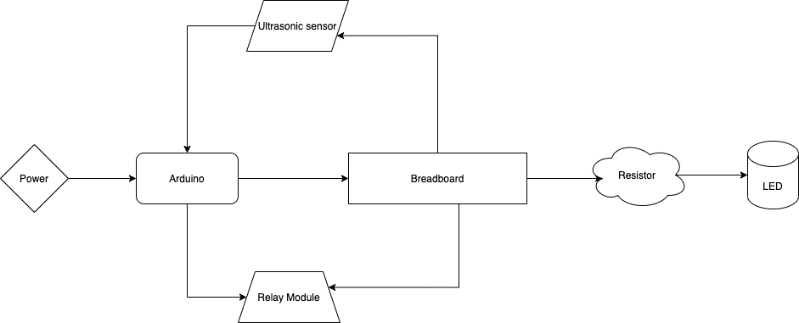

Figure : Hardware Architecture of the project

The above diagram showcases the hardware architecture where Arduino, breadboard, resistors, LEDs, ultrasonic sensor, and relay agent are used accordingly.

### Circuit Diagram

An electrical circuit is represented graphically in a circuit diagram. A circuit diagram is a simplified graphical depiction of an electrical circuit, often known as an electrical diagram, elementary diagram, or electronic schematic. Electrical and electronic equipment is designed, built, and maintained using circuit diagrams (BYJU'S, 2022). The proposed circuit diagram for the project is mentioned below.

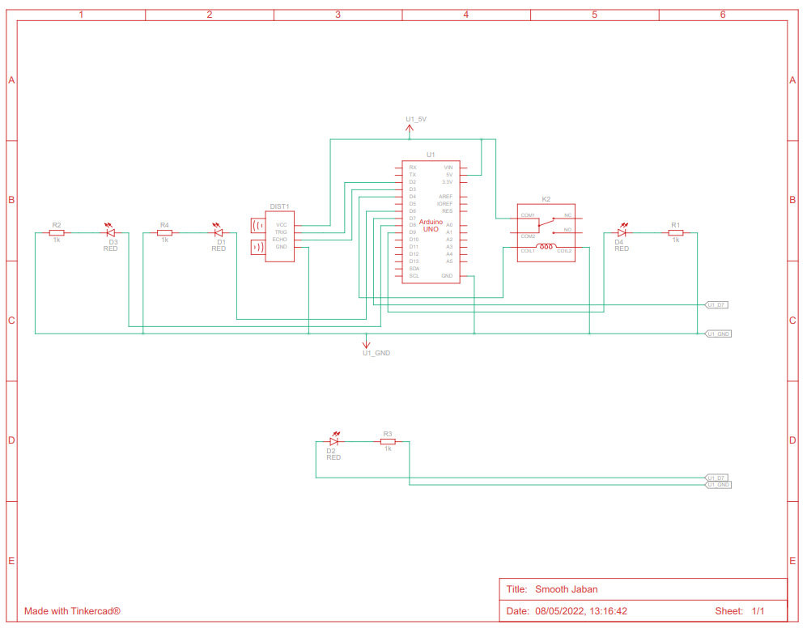

Figure : Circuit diagram of the project

The above picture illustrates the circuit diagram of the system. It merely contains the graphical representation of the hardware architecture in a more sophisticated form.

### Flowchart

Figure 3: Flowchart of the system

## Requirement Analysis

### Hardware

* **Arduino**: Arduino is an electronic device that can read, process, and output data in the same way as a computer can. It's an open-source platform that may be customized to suit your needs. Arduino is utilized in IoT projects all over the world, and it benefits both teachers and students. We used an Arduino with a breadboard, an ultrasonic sensor, and a relay module in our project.
* **Breadboard**: A breadboard, often known as a protoboard, is an electronic device used in conjunction with Arduino or other devices such as the Node MCU. The name comes from the fact that these breadboards do not require soldering and are reusable. In our project, we utilized a breadboard to connect to the Arduino, and we used resistors and LEDs according to our Arduino program.
* **Ultrasonic Sensor**: Ultrasonic sensors are ultrasonic sensors that use ultrasonic waves to calculate distance. The ultrasonic waves are emitted by the sensors in this device, and the reflected waves are received by the object or target. The distance between the sensor and the object is calculated using the period between emission and reception. We attached Ultrasonic sensors to the breadboard and Arduino in our project, and the distance measured is indicated by the LED on the breadboard.
* **Relay module:** The electromagnet is used to operate the relay module. It's an electrical switch that converts minor electrical stimuli to large ones using electromagnetism theory. We attached our relay module to the Arduino and programmed it as needed in our project.
* **LED**: LEDs, or light-emitting diodes, are semiconductor devices that illuminate when power is applied to them. In our project, we used an LED to represent the water distance, which was computed using an ultrasonic sensor.
* **Resistors**: The devices that control the flow of electrical current are known as resistors. Resistors aid in the control of current flow in a circuit, ensuring that only the required quantity of energy passes through. We utilized resistors to light the LEDs in our device so that they could be lit with any voltage.
* **Jumper Wires**: Jumper wires are just cables that connect two places together. Jumper wires were used throughout our project. We used it to connect an Arduino to a breadboard, as well as ultrasonic sensors and a relay module.

### Software

* **Arduino IDE**: Writing code and uploading it to the board is simple with the open-source Arduino Software (IDE). Any Arduino board can be used with this software.

# Development

In this section of the report, the step-by-step process of the development of the project is mentioned. The overall situation of the project from planning to execution is mentioned here.

## 3.1. Planning and Design

For this particular project, an IoT based Water tank monitoring and management system was to be developed which would be helpful in solving the water overflow and water scarcity issue faced in each and every household. To start any project, planning and vision of what the final would look like is must. The same is true for this project as well.

At first, the thought was to develop a water tank monitoring system only but that was further upgraded to management as well thus, the overall project was finalized as water tank monitoring and management system. The original idea behind this project was because of the problem faced by every household.

As it is known that more than once in our lives, we have faced the problem of water overflow or water shortage. Hence, this IoT system is not only a project but a step towards the solution of the problem mentioned above. Different devices were used during the completion of this project. Each of those devices are mentioned properly in section two i.e., Background part.

## Resource Collection

A number of devices and tools were needed to completely showcase the progress of this project. Those devices were to be managed from different sources. Around half of the devices were managed from the resource department of Islington college itself. Each of the group members provided their assist in finding the resources for this project. The devices obtained from the resource department at Islington college are:

* Arduino
* LEDs
* Jumper Wires
* Ultrasonic Sensor
* Breadboard
* Relay Module

Some of the resources obtained except from the Islington college resource department are some extra jumper wires and a buzzer, which was discarded and relay module was used instead.

## System Development

The system is an IoT based Water monitoring and management system which reduces the risk of water overflow and shortage different devices were used to complete this project. At first an Arduino was used to connect to our pc. One of the reasons to connect the Arduino was to give power supply to the Arduino. Also, it was done to initiate the coding.

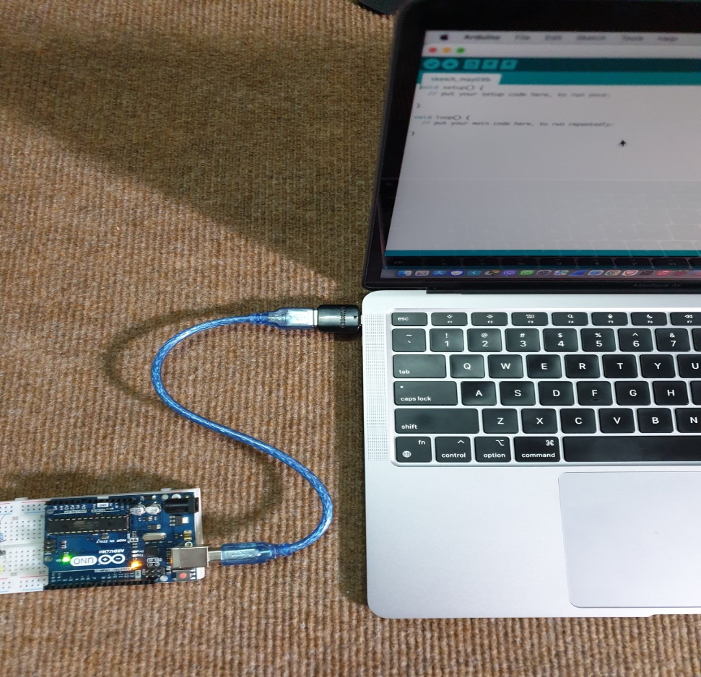

Figure 4: Connecting Arduino into pc

In the above figure, the first step was initiated. The Arduino was connected into the pc to provide power supply to it and to initiate the coding for the program.

After the breadboard was powered on since every device and their mutual connection through the wires were connected in the breadboard.

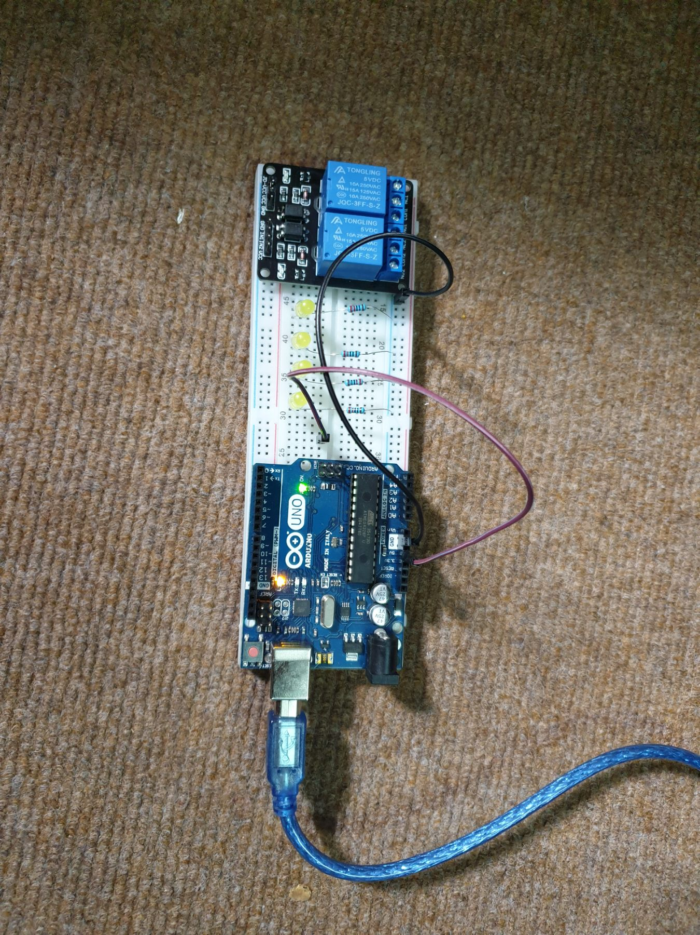

Figure : Providing power to breadboard

Breadboard was needed to provide connection to different devices using different wires. Thus, it was necessary to power on the breadboard.

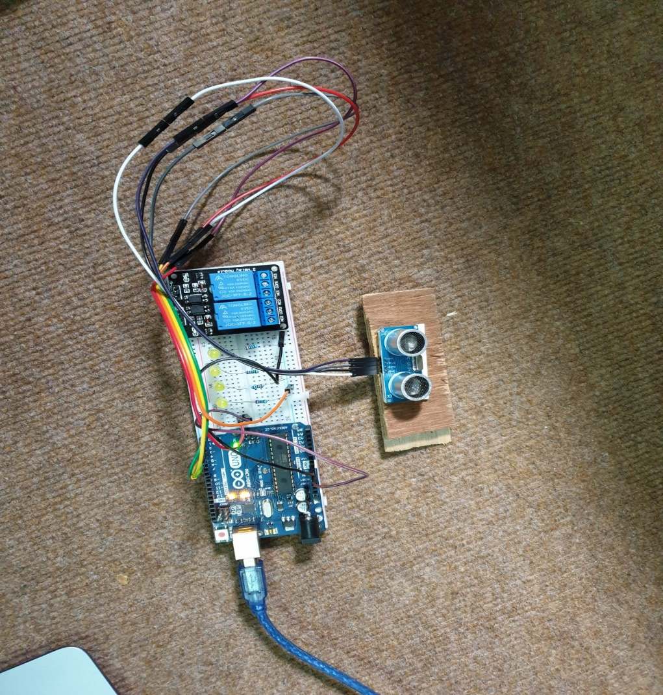After providing power supply to the breadboard, ultrasonic sensor was connected to the breadboard for power supply but the input and output was collected by the help of Arduino.

Figure : Ultrasonic connected to the breadboard

The above figure illustrates the connected of ultrasonic sensor to the breadboard. Even if the sensor is connected to the breadboard, the input and output result is provided by the Arduino.

After that LEDs were installed into the breadboard. The use of LEDs is that with the help of ultrasonic sensors, the level of water can be known when the bulbs are lighted.

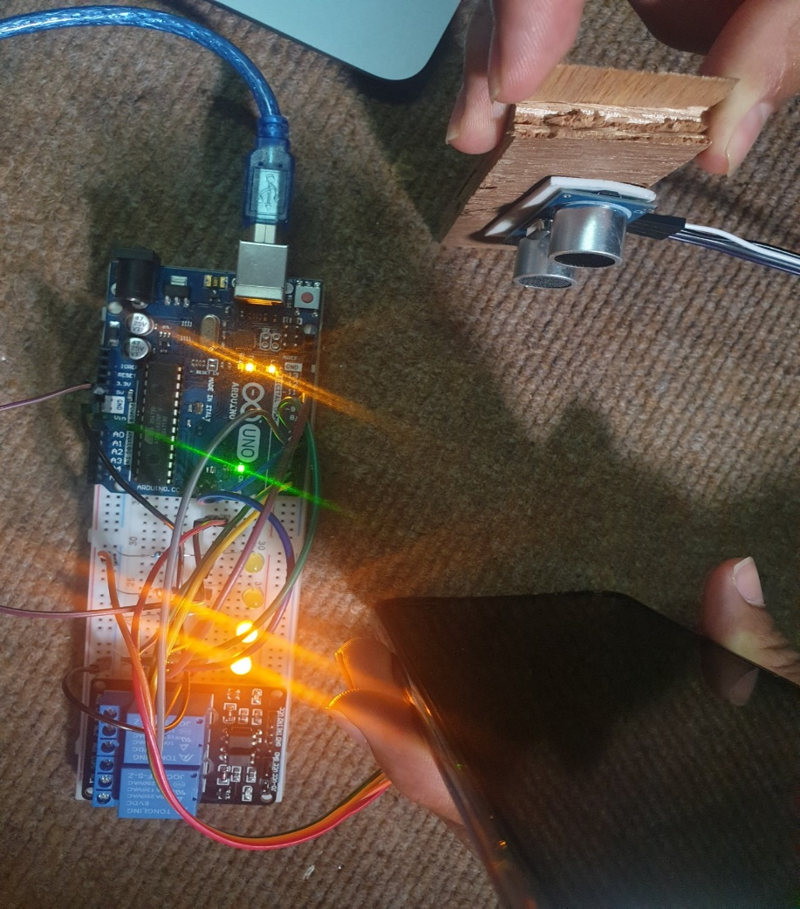In figure 6, according to the code, when half the distance is reached, two bulbs will light be indicating that the level of reached a certain point.

Figure : LED light in breadboard

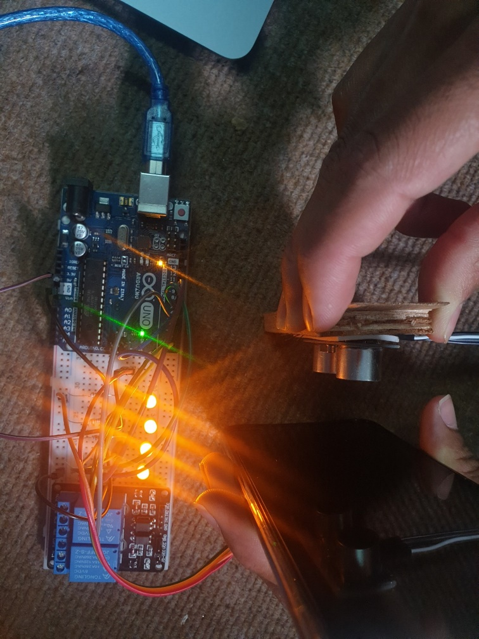

Figure : LED light in breadboard - 2

In the figure above, in accordance with the coding, when the distance is reached at its maximum, four bulbs will light.

Now, the relay module was added into the breadboard which works as on and off switch of the motor.

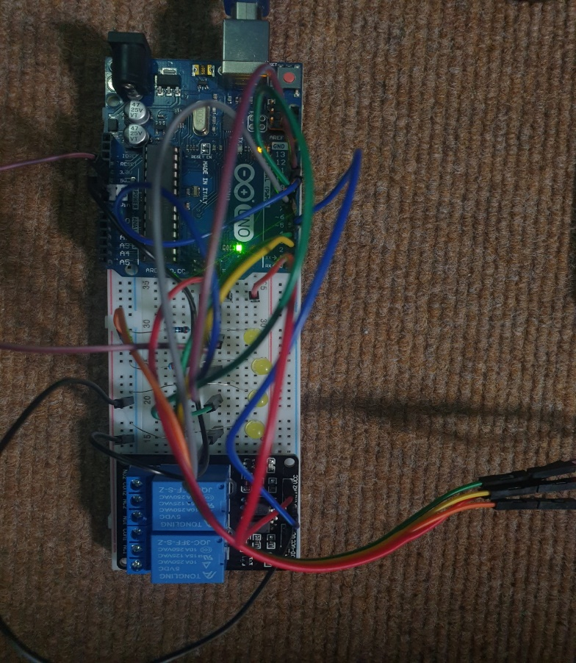

Figure : Inserting relay into breadboard

# Results and Findings

## 4.1. Result

Even before starting the project, the idea itself was enough to visualize the outcome of the project. The project, at its end, provided an IoT based Water Tank monitoring and management system which would somewhat solve the water crisis problem faced in the everyday household.

The final system developed was integrated with a bulb which will glow when the water level has reached below the minimal point and the same would be done when the level of water reaches the maximum point. The system was checked thoroughly and the outcome was successful.

The system developed at the end was able to solve the water overflowing and water shortage crisis which is the primary problem of every household today. This Water Tank monitoring and management system practically solved the problem as shown in the findings section of this report.

## Findings

In this section, different test cases are included to show the successful running of the project with 100% successful result. The test cases are mentioned below:

### Test – 1

|  |  |
| --- | --- |
| Test No: | 1 |
| Objective: | To show the execution of the code. |
| Action: | Code was written, verified and uploaded onto the Arduino by the help of Arduino IDE application. |
| Expected  Result: | The code would be compiled successfully without any error. |
| Actual  Result: | The code was executed successfully without any error. |
| Conclusion: | Test was Successful. |

Table : Testing 1

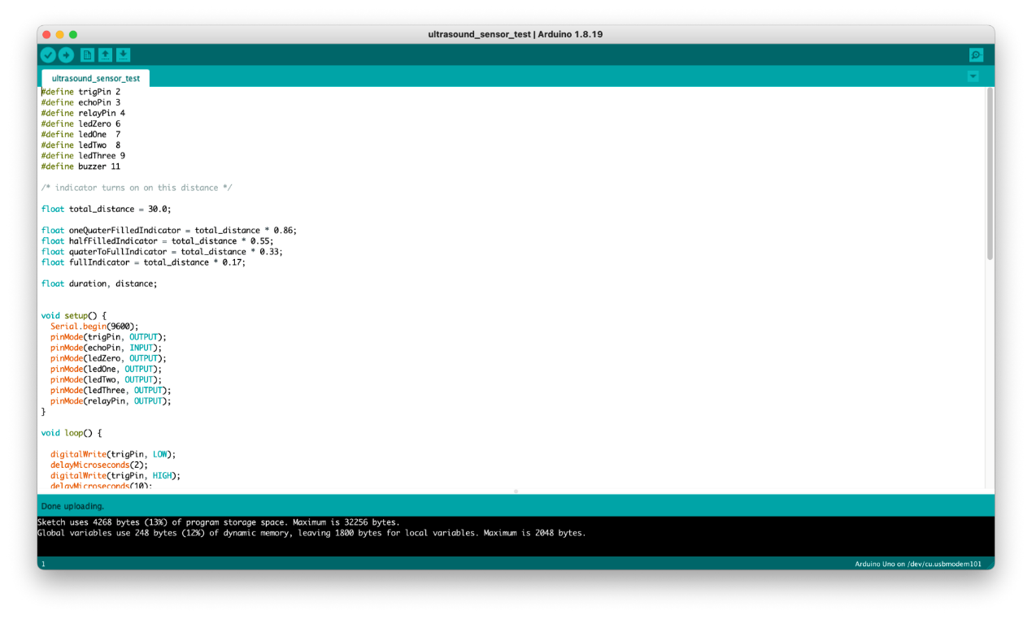

Figure : Successful execution of code

### Test – 2

|  |  |
| --- | --- |
| Test No: | 2 |
| Objective: | To check the distance using ultrasonic sensor |
| Action: | An object was placed in front of ultrasonic sensor. |
| Expected  Result: | LED would blink according to the distance provided in the code and serial monitor should show distance calculated by ultrasonic sensor. |
| Actual  Result: | LED blinked according to the distance provided in the code and serial monitor should show distance calculated by ultrasonic sensor. |
| Conclusion: | Test was Successful. |

Table : Test - 2

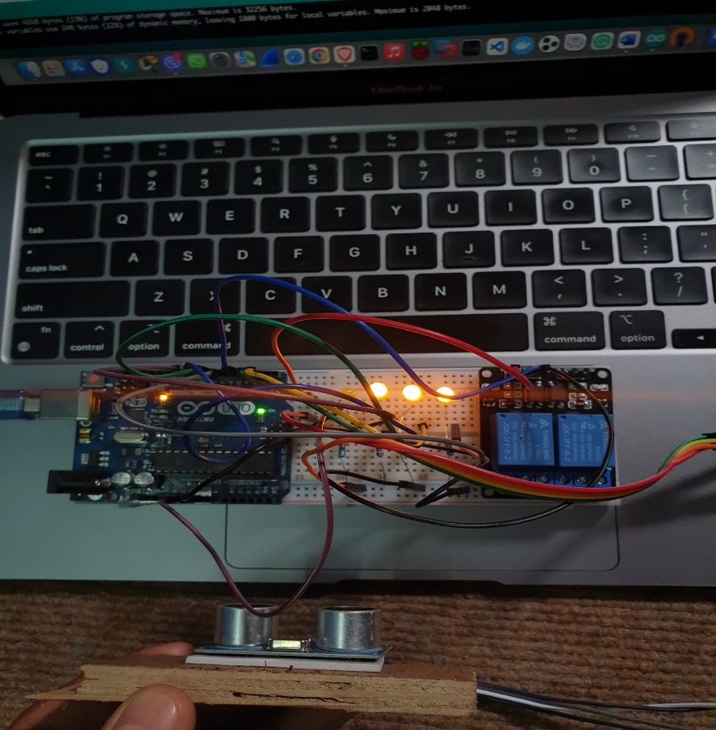

Figure : LED blinking in accordance to the distance

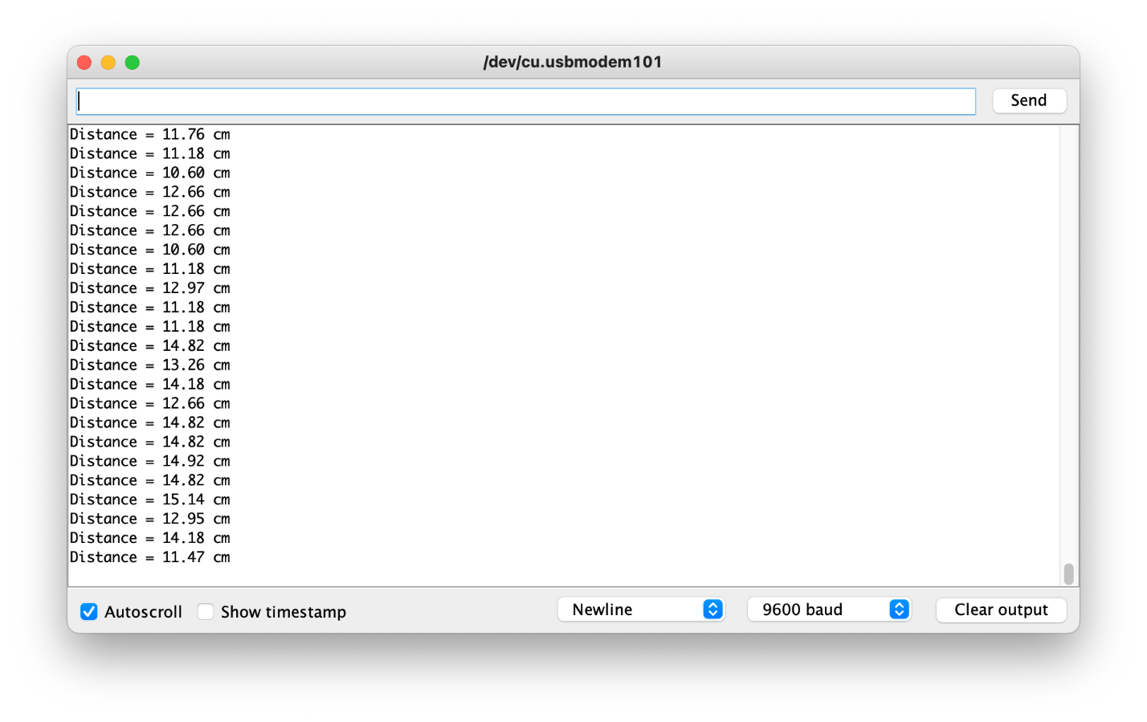

Figure : Serial monitor showing the distance provided by the ultrasonic

### Test – 3

|  |  |
| --- | --- |
| Test No: | 3 |
| Objective: | To check the working of relay module |
| Action: | Code was executed and water level was checked accordingly. |
| Expected  Result: | When the LED level is full, relay should cut off electricity and vice versa. |
| Actual  Result: | When the LED level is full, relay cut off electricity and vice versa. |
| Conclusion: | Test was Successful. |

Table : Test - 3

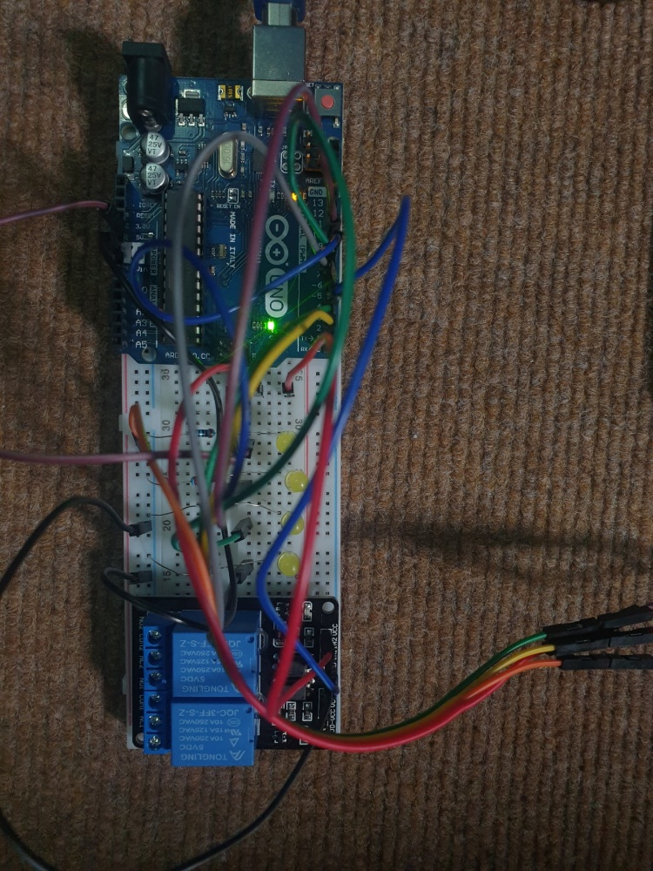

Figure : relay during on state

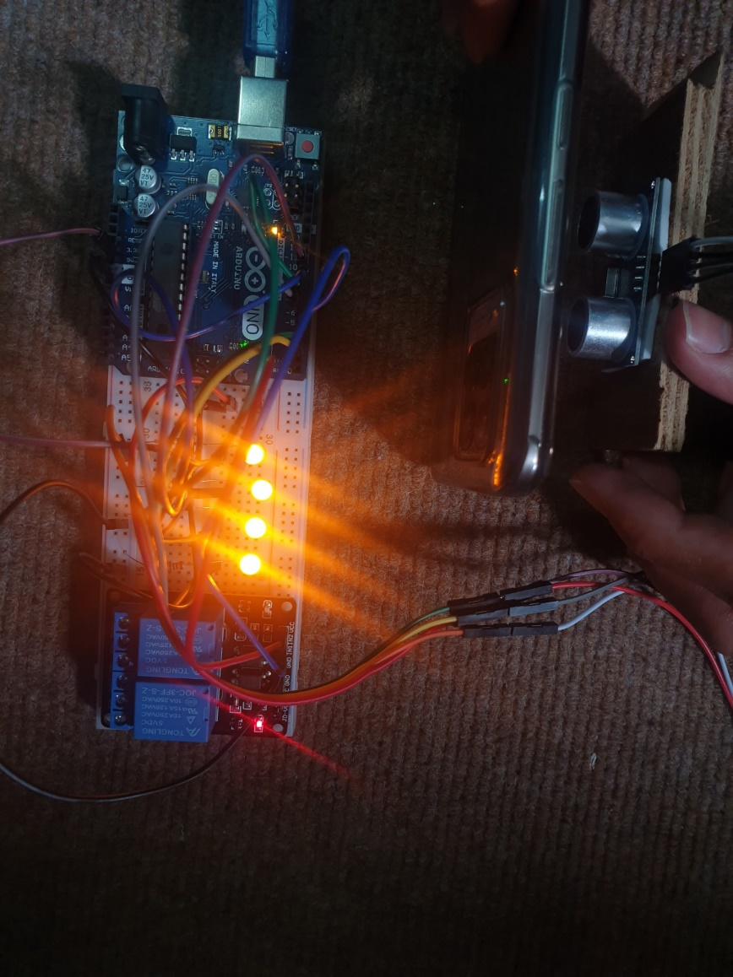

Figure : Relay during off state indicated by the red light

### Test – 4

|  |  |
| --- | --- |
| Test No: | 4 |
| Objective: | To check the working of the whole system using live water scenario. |
| Action: | Water was added in the beaker at none, middle and full amount and the outcome was checked. |
| Expected  Result: | When the water level is minimal, the LED would be off, two LEDs would light at middle, and four LEDs would light at maximum water level. |
| Actual  Result: | When the water level is minimal, the LED was off, two LEDs was lighted at middle, and four LEDs was lighted at maximum water level. |
| Conclusion: | Test was Successful. |

Table : Testing - 4

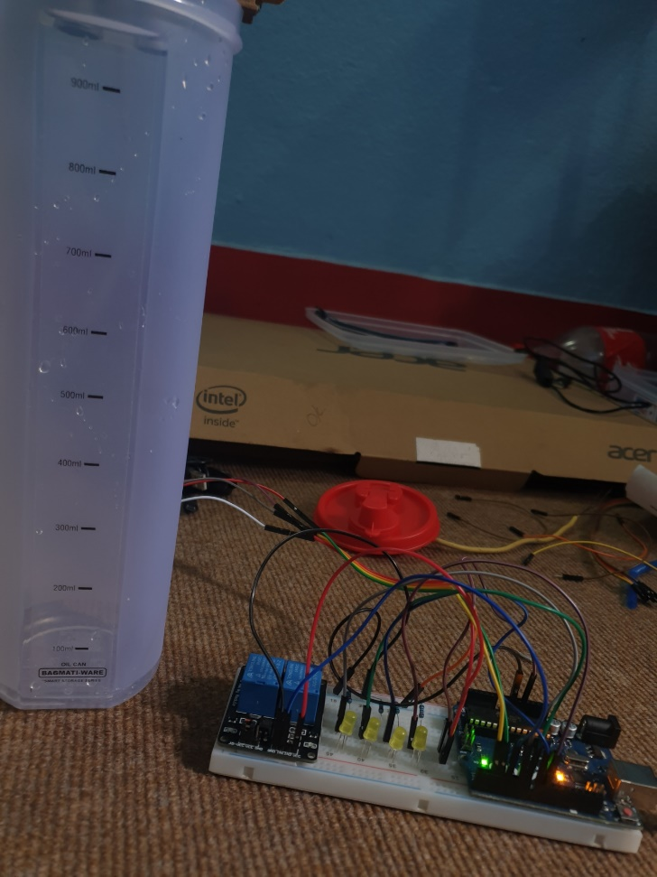

Figure 15: Testing with water level at minimum

In the above figure, all the system was powered on and then water level was kept at minimum hence, no LED bulbs light up and the relay module is at on state.

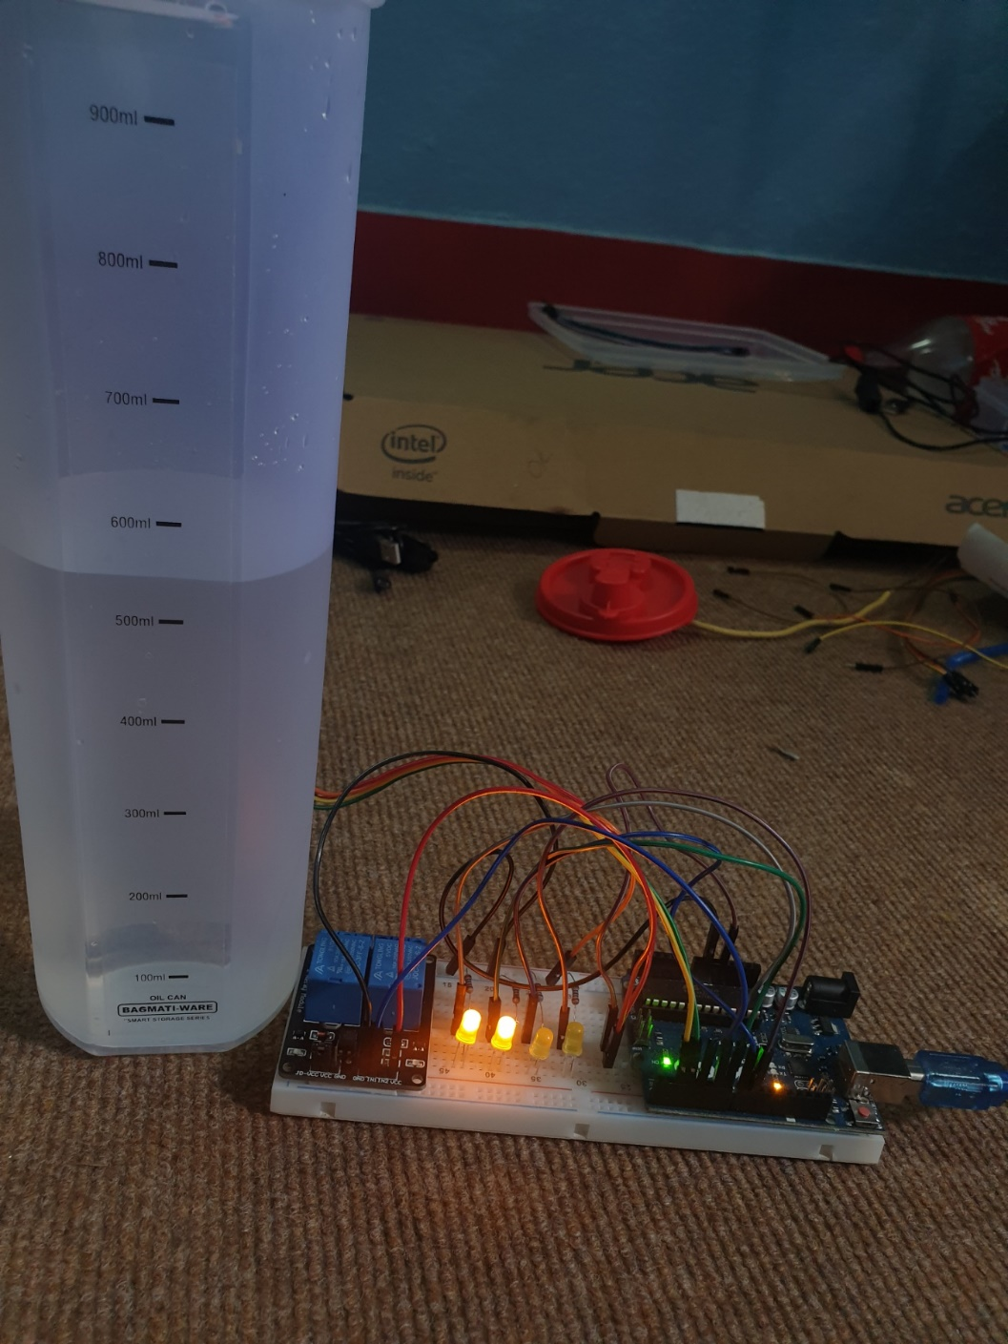

Figure 16: Water level was kept at middle and checked

In the figure above, the water level was inside the beaker was at middle point. Thus, two LED bulbs light up indicating that the level of water has reached at middle capacity.

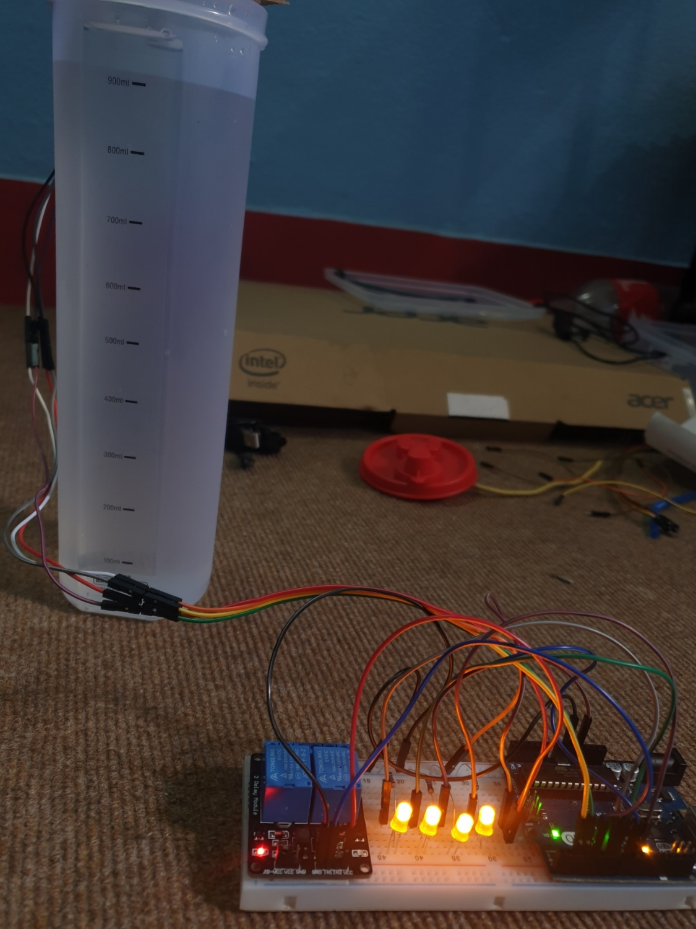

Figure 17: Water level at maximum and checking

In figure 16, when the level of water was at maximum point, four LED bulbs light up indicating that the beaker is full. The red light indicates that the relay is now turned off.

# Future Works

This water level monitoring and management system has a lot of possibilities in the future. The developed project is just the tip of the iceberg. The future endeavours are quite interesting and very useful in real life. First of all, this is a miniature version of what the real-life water monitoring and management system looks like. So, further upgrading the project, a giant size product could be developed to actually use in the water tanks available at household.

Also, the upgrade could also provide the users with the timely message regarding the level of water in the tank. This would become helpful to turn on/off the device when necessary. Also, in the near future when the system is integrated with wifi, the system could be monitored using the same. At the moment, the switch has to be on and off manually but after integrating it with wifi, the users would be able to do that using wifi facility.

# Conclusion

Water scarcity and overflow have been issues with every water tank in every home. Checking whether the water level has reached a certain level and being warned of it might be beneficial in preventing overflow and scarcity at a specific period. By warning about the water level when it crosses the threshold limit, the developed Water Monitoring and Management system helps to decrease water waste due to overflowing. When the water level falls below the critical level, the system alerts us, so we know when to refill the tank. Because overflowing tanks are a major source of water waste, this proposed technology might be extremely beneficial. This particular project made every student aware about the IoT systems, their use in daily life and how it can be integrated to make such a system which would be helpful in controlling and solving the daily problems in our lives.

# References

BYJU'S, 2022. *Circuit Diagram And Its Components - Explanation With Circuit Symbols.* [Online]   
Available at: https://byjus.com/physics/circuit-diagram/  
[Accessed 1 5 2022].

Nishmitha, et al., 2019. Water Tank Monitoring System. *IJERT,* 7(8), p. 4.

sciencedirect.com, 2020. *Hardware architecture - ScienceDirect.* [Online]   
Available at: https://www.sciencedirect.com/science/article/pii/B9780128234884000035  
[Accessed 1 5 2022].

# Appendix

## Codes

#define trigPin 2

#define echoPin 3

#define relayPin 4

#define ledZero 6

#define ledOne 7

#define ledTwo 8

#define ledThree 9

#define buzzer 11

/* indicator turns on on this distance */

float total_distance = 25.0;

float oneQuaterFilledIndicator = total_distance * 0.86;

float halfFilledIndicator = total_distance * 0.55;

float quaterToFullIndicator = total_distance * 0.33;

float fullIndicator = total_distance * 0.17;

float duration, distance;

void setup() {

Serial.begin(9600);

pinMode(trigPin, OUTPUT);

pinMode(echoPin, INPUT);

pinMode(ledZero, OUTPUT);

pinMode(ledOne, OUTPUT);

pinMode(ledTwo, OUTPUT);

pinMode(ledThree, OUTPUT);

pinMode(relayPin, OUTPUT);

}

void loop() {

digitalWrite(trigPin, LOW);

delayMicroseconds(2);

digitalWrite(trigPin, HIGH);

delayMicroseconds(10);

digitalWrite(trigPin, LOW);

duration = pulseIn(echoPin, HIGH);

distance = (duration / 2) * 0.0343;

Serial.print("Distance = ");

if (distance >= 400 || distance <= 2) {

Serial.println("Out of Range");

}

else {

Serial.print(distance);

Serial.println(" cm");

if (distance <= fullIndicator) {

tone(buzzer, 500, 80);

digitalWrite(relayPin, LOW);

digitalWrite(ledZero, HIGH);

digitalWrite(ledOne, HIGH);

digitalWrite(ledTwo, HIGH);

digitalWrite(ledThree, HIGH);

} else if (distance <= quaterToFullIndicator) {

digitalWrite(ledZero, HIGH);

digitalWrite(ledOne, HIGH);

digitalWrite(ledTwo, HIGH);

digitalWrite(ledThree, LOW);

} else if (distance <= halfFilledIndicator) {

digitalWrite(ledZero, HIGH);

digitalWrite(ledOne, HIGH);

digitalWrite(ledTwo, LOW);

digitalWrite(ledThree, LOW);

} else if (distance <= oneQuaterFilledIndicator) {

digitalWrite(ledZero, HIGH);

digitalWrite(ledOne, LOW);

digitalWrite(ledTwo, LOW);

digitalWrite(ledThree, LOW);

} else {

tone(buzzer, 500, 10);

digitalWrite(relayPin, HIGH);

digitalWrite(ledZero, LOW);

digitalWrite(ledOne, LOW);

digitalWrite(ledTwo, LOW);

digitalWrite(ledThree, LOW);

}

delay(50);

}

delay(50);

}